The second city in association with the wooly mammoth theater put on one part laugh riot, one part group therapy session known solely as dance like black people are watching. This is a summary and analysis for those of us who were not able to make it. It was a contemporary theater production with instead of acts and an overarching story there were a series of sketches and on the fly improv, it created a distinct stratified audience one audience member stood out specifically to me an older white American gentleman who had a steeley face rthroughtout the entire production, i did not ask him his name or what he thought but judging solely off of his body language throughout the show he disapproved.

It opened on a spoof of Dr. Martian Luther King’s renowned i have a dream speech with dramatic yet pertinent statements regarding the black community of today “I HAve a nightmare that my four little children continued to be judged by the color of their skin and not by the content of their character” and “I had a nightmare taht a xenophobic miysoginistci rac tiny handed crook, was electe president of these united staesit was as you can imagine a Shitty, shitty shitty fucked up ass nightmare. ” wich illiceted 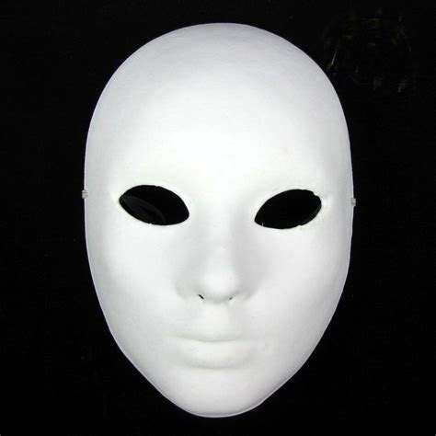

And when i awme iti relixed it was more tahn just a night mare it was my reality and liek our amce before hope must previalpeopel of the wooly mammoth theater please stand for the new national anthem” to the play kendrick llamars “not liek us” . All the cast members were donned in white masks as the song started the cast was bathed in light and began to mr llamars song beckoning the audience to dance althehwuile . No one did. After their routine they called out “if youre black and proud say ‘hell yeah’ ‘if youre black and proud say hell *MOTHERFUCKING* yeah ’ ‘Its going to be a diffrent show here tonight’“. True to the crowdwork it was ittruly was.

“Are you ready to seeblack joy was received with thunderous applause ”

The first sketch was a brief batman commentary when upon finding out that the joker was spotted on the intersection of florida and georgia avenue begins to cower in fear and “rhetorts you better call superman and i aint going to south east nether”

The second sketch was about sycophantal praise in the young black community taht rather giving genuine support and praise for someone accomplishments and personality all they could respond with “okay girl” and “peiod!” in response to a shallow observations sucha sa her hair and nails and clothes.

The skectha after taht was in the setting of family feud with the question they were competing for being what makes blak people curse, after deliberation the family settles on anything wich is responded by steve harvey with elation at their success

The next sketch is the first in a recurring horror sketch

The cast is huddled up in a corner with a single beam fo light illuminating them with cliched erie music playing as they all commemorate omn their new found situation (an Overnight Scenario if you will \*haha\* ) one of the “survivors” philosophies that perhaps the monster is a dark reflection of humanity wich bores the fellow “survivors” after fighting with each other they and another person getting dragged of stage one member remarks that she is a natural born leader and that she is the manager of the shaw howard metro pcs the castmemebre get picked off one by one until tehre were three wich open states we may not be able to deceds who gets saved but we may be able to decide whos next and begins chose with her justification being she is an enlightened black american and a senator when she is about to be taken another cast member grabs hold of her and ask steh senator who did you vcote for wich the senator rhetorts that she believes in faith baised- and at that point the person holding on to her in disgust oputs her hands uop and walks away for her to be taken bu the entity

At this point i was about to choke this all up to a waste of money that another piece of black media trying to give albeit much needed critiques of the black community inadvertently creating the exact same shallow media that it is supposedly decrying, until i saw the next sketch

Black therapy is a sketch about the black communitis general distrust and downplaying of mental disorders and the usefulness of thrapy and counsoling, in wich his black therapist encouriges him to seek alternative and faith based “folk” medicine with exaggerated religiosity, only to reveal that she was performing an elaborate spontaneous psychodrama to get her to acknowledge the shortcomings of the black community so that he may begin to heal.

“Leave us alone”

Leave us alone is a musical number and one of the weaker parts of the act in wich the ccast members implore the world leave tehm unmolested as tehy “try to keep their peace in a world that wants tehm in pieces”

Satirical superpacs

The next sketch was a satirical adread of superpac who supposedly had an involvement in the 2024 election there were more but there werent

“Citizens united

Texas tea party

Make america . . . again

Move to the left association, move to the right association, cha cha real smoth

Orange is the new pac

Baby got pac

Pac dat ass up”

The next sketch was a play on cheesey fitness programming targeted towards women, at first encouraging women to practice and pantomime pastoral and mundane tasks such as going to the store and refuling their car devolves after finding out that their husband is having an a ffair.

The frito lay fiasco I will dub it.

The play finally ends on a sketch about

Image sources

http://www.dhgate.com/product/plain-white-masks-for-sale-full-face-paper/157048447.html